Press release
For immediate release
Contact | Elina Kuusio / 074 4046 9384 / elinakuusio@redcross.org.uk  Out of hours/ 020 7877 7557 / press@redcross.org.uk
Images available | https://storieshub.redcross.org.uk/?c=20778&k=a212abecf4
Spokespeople available on request
London exhibition of Britain’s trailblazing female war artist, Doris Zinkeisen, to celebrate VE Day 80th anniversary
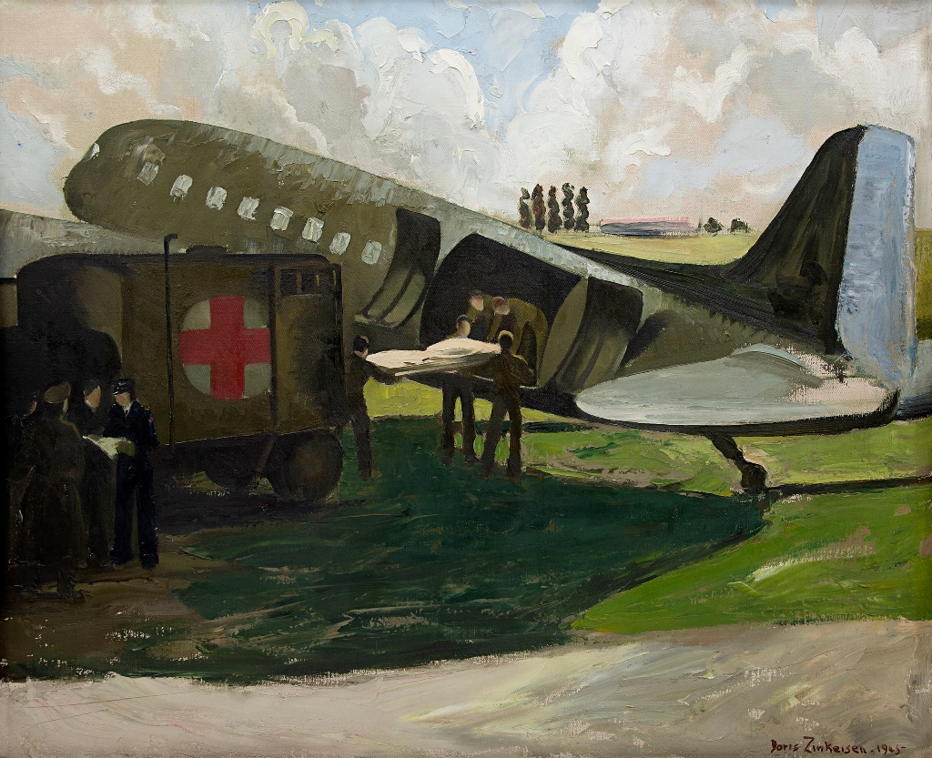
The British Red Cross is thrilled to announce a four-day London exhibition of Britain’s trailblazing female war artist, Doris Zinkeisen (1897–1991), to celebrate the 80th anniversary of Victory in Europe (VE) Day. The free public exhibition will take place at the Oxo Tower in Southwark, central London between May 8th and May 11th.
The ‘Brushstrokes from the Front Lines’ exhibition shines a light on the extraordinary life and art of the renowned painter. The collection on display includes several original paintings by Doris Zinkeisen – now unveiled to the public for the first time in decades.
Doris Zinkeisen was a pioneering artist, widely recognised for her realist painting style and striking society portraits. From the 1920s to the 1950s, she was one of Britain’s most influential artists, breaking barriers in a male-dominated art scene.
Zinkeisen’s evocative works stand as a powerful testament to women’s vital role in documenting and interpreting war. She was commissioned by the British Red Cross and Order of St John to record their work and what she saw for the British public, highlighting the realities of war before TV cameras and 24-hour news coverage.
She was one of the first artists to enter the infamous Bergen-Belsen concentration camp in northern Germany after its liberation on 15th of April 1945.
Her paintings not only captured the relief work the Joint War Organisation of the British Red Cross and Order of St John carried out close to the front line in Europe, but also revealed the disturbing death, sickness and suffering of those in captivity, serving as a vital historical record.
Béatrice Butsana-Sita, Chief Executive Officer of the British Red Cross, said:
“The British Red Cross is proud to showcase the work of gifted artist and dedicated humanitarian Doris Zinkeisen in a brand-new exhibition to celebrate the 80th anniversary of VE Day.
“The exhibition not only honours her artistic achievements but reflects the unwavering commitment of countless volunteers – like Doris who was a British Red Cross and St John Ambulance Brigade volunteer nurse – during the Second World War.
“I am inspired every time I learn about the people who have played an important part in our history. Doris’ work is a powerful reminder of how art can capture history and the power of humanity.”
Charlotte Johnstone, granddaughter of Doris Zinkeisen, said:
“Doris, our grandmother, was a huge presence and influence in our lives. She was a courageous, loving, funny and formidable character in equal measure.
“She was a trailblazer. She showed an unbelievable drive, a zest for life, clarity of thought and courage in a male dominated world and a point in history that was beyond challenging for most. She was a creative force through and through.”
Key details
Dates: 8 May 2025 to 11 May 2025
Opening Hours: 11am - 6pm daily
Admissions: Free
Curator: Mehzebin Adam-Suter
Address: gallery@oxo, Oxo Tower Wharf, Barge House Street, London, SE1 9PH
Original paintings highlights
The original artworks include four large oil paintings owned by the British Red Cross Museum and Archives such as Doris Zinkeisen’s famous depiction of the burning of Bergen-Belsen concentration camp in May 1945, and six watercolour paintings owned by the Museum of the Order of St John.
The oil paintings have been briefly exhibited just once before – in the late 80s – while the watercolour paintings have been exhibited once in the 1990s – making the four-day window this May a rare opportunity to see these historical artworks previously hidden in museum archives for decades.

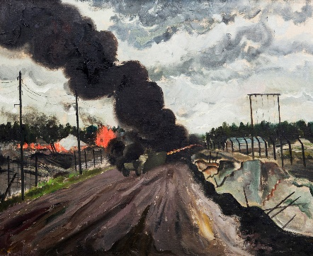 | The burning of Bergen-Belsen (oil on canvas, 1945)  The overcrowded and unsanitary conditions of the Bergen-Belsen concentration camp in Germany led to diseases like typhus. After the evacuation, the huts were burned to prevent the spread of disease. From and © The British Red Cross Museum & Archives (Photographer: Karolina Heller).
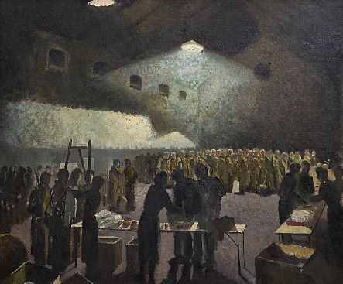 | Repatriation of prisoners of war (oil on canvas, 1945)  A British Red Cross relief team distributes clothing to recently liberated prisoners of war in Brussels. The muted colours convey bleakness and hardship, while the scene captures the compassionate efforts of humanitarian workers. From and © The British Red Cross Museum & Archives (Photographer: Karolina Heller).
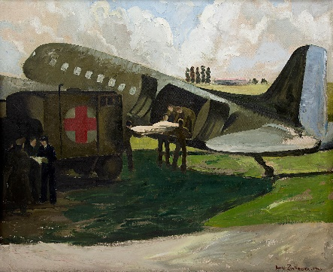 | Air ambulance being loaded near Bruges (oil on canvas, 1945)  An ambulance crew loads a wounded soldier onto an air ambulance near Bruges, Belgium. The vehicles highlight the complexity and urgency of wartime evacuations. From and © The British Red Cross Museum & Archives (Photographer: Karolina Heller).
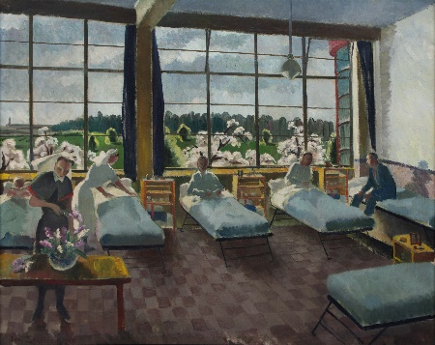 | C Ward, 101 British General Hospital, Louvain (oil on canvas, 1945)  A portrayal of a calm hospital ward where wounded soldiers recover under the care of medical staff and volunteers. In the foreground, a nurse arranges flowers as patients rest and talk. From and © The British Red Cross Museum & Archives (Photographer: Karolina Heller).
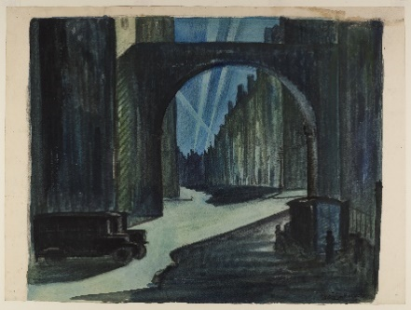 | Night air raid on London (watercolour, black chalk and gouache on paper, 1942)  Searchlights scan the sky as figures move through dimly lit streets, seeking shelter. The scene reflects the tense atmosphere of wartime London. From The Museum of Order of St John, London. The Priory of England and the Islands (RC no. 1077265).
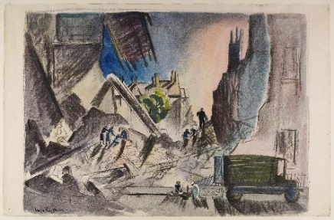 | Mobile unit responding to an air raid (watercolour, black chalk and gouache on paper, 1942)  A mobile unit at work after an air raid. The scene captures volunteers navigating the devastation to provide emergency aid. From The Museum of Order of St John, London. The Priory of England and the Islands (RC no. 1077265).
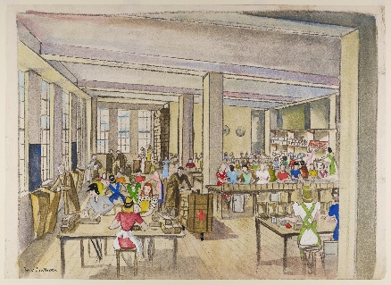 | Packing food parcels for prisoners of war (watercolour, pencil and gouache on paper, 1942)  By the end of 1943, around 190,000 parcels were hand-packed by volunteers each week. These became known as ‘the Red Cross lifeline’, providing essential nutrition for those in captivity. From The Museum of Order of St John, London. The Priory of England and the Islands (RC no. 1077265).

ENDS
Notes to editors:
About the British Red Cross
For over 150 years, the British Red Cross has helped people in crisis, whoever and wherever they are. With millions of volunteers in over 190 countries, the British Red Cross is part of an international humanitarian Movement that’s there for people before, during and after a crisis. Together, we are the world’s emergency responders. www.redcross.org.uk
About the Museum of the Order of St John
The Museum tells the fascinating story of the Order of St John from its origins in eleventh century Jerusalem, through to its modern role with St John Ambulance and the St John Eye Hospital. www.museumstjohn.org.uk
About the Oxo Tower Wharf
Oxo Tower Wharf is an award-winning mixed-use building, home to a creative community of designer-maker studios and showrooms, gallery and event spaces, shops, and cafes all at the heart of London’s South Bank and Bankside. Right on the riverside, visitors can browse, buy and commission from independent small businesses ranging from fine jewellery, luxury ceramics to neon lighting, leather goods and much more, in addition to fine dining at the world-famous rooftop restaurant. The iconic building with its famous art deco tower is owned and managed by Coin Street, a local social enterprise creating a thriving, diverse, and welcoming place for people to live, work and play. https://www.coinstreet.org/

