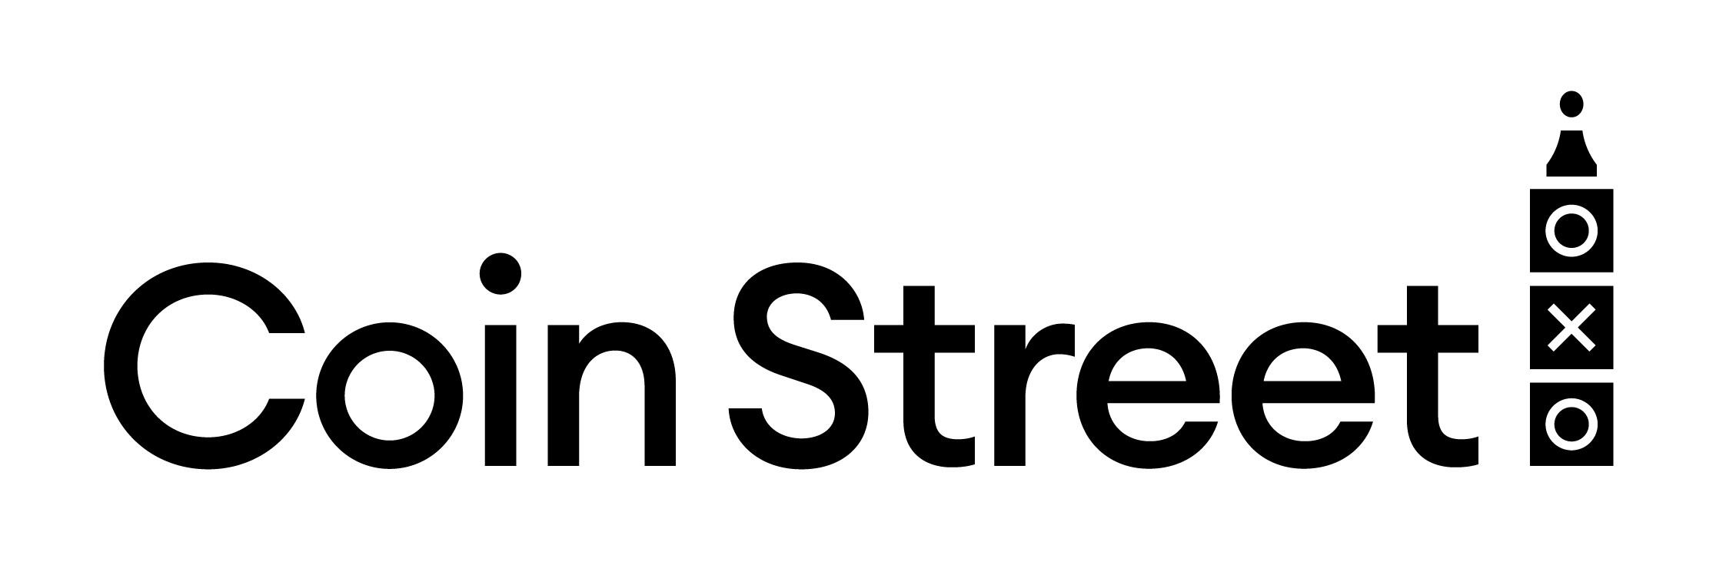

PRESS RELEASE
FOR IMMEDIATE RELEASE
Date: 27 August 2025

Gabriel’s Wharf Arts Festival
A Celebration of Creativity and Community
Saturday 6 & Saturday 20 September 2025
Gabriel’s Wharf, Upper Ground, London SE1 9PP
Admission: FREE

This September, Londoners are invited to rediscover one of the South Bank’s best-kept secrets as Gabriel’s Wharf unveils its biggest creative celebration yet: the highly anticipated return of the Gabriel’s Wharf Arts Festival 2025, following last year’s resounding success.
Taking place across two Saturdays: 6 and 20 September this free, family-friendly festival offers a vibrant mix of live music, spoken word, art and craft activities, and riverside revelry, all set within one of London’s most characterful independent quarters.
A Creative Hub with Heart
Since the 1980s, Gabriel’s Wharf has been a nurturing ground for artists, designers, musicians, and independent businesses. This year’s festival honours that legacy with a line-up that celebrates local talent, cultural diversity, and community spirit.
Expect everything from soulful jazz and folk guitar to street theatre, hands-on art workshops, comedy, roving performers, and readings by celebrated authors; all nestled among independent shops, studios, and al fresco eateries along the Thames Path.
“Gabriel’s Wharf has always been a place where creativity thrives. This festival is a chance for Londoners to reconnect with the artists, makers, musicians, and shopkeepers who give this corner of the South Bank its unique heart and soul.”
said: Hannah Thomas, Marketing Manager, Coin Street

Festival Highlights
Live Music & Spoken Word
- Alina Bzhezhinska & Tony Kofi: award-winning harp and saxophone duo
- Doolally Tap: prohibition-era jazz bursting with energy
- City Academy Songbirds feat. The Sheens: uplifting gospel, pop, and musical theatre
- Tom Chivers: readings from London Clay, exploring London’s forgotten layers
- mex.fS: hypnotic ‘lap tap’ guitar performances
- Tamashii School of Wadaikoo-Do: powerful traditional Japanese drumming
- Tia-zakura: spoken-word storytelling and rhymes, roaming the Wharf
Street Performers & Roving Comedy
- That Guy With A Ball: mesmerising crystal ball juggling
- Surprise comedy acts and street performances throughout both days
Interactive Art & Activities
- Bunting making for all ages
- Mark making with Tami St George Hedley using paint, sticks, and bubble wrap
- Drop-in sessions outside Skylark Galleries
- Poetry On The Hour at Potters' Yard Arts
Festival Offers & Local Shopping
- Free dessert with mains at Paradiso (mention "Arts Festival")
- 10% off framed prints and artists' books at Potters’s Yard Arts
- Exclusive in-store discounts at TAP by Gita’s Portal
Event Info
- Admission: Free – no ticket required
- Dates: Saturday 6 & Saturday 20 September 2025
- Time: Activities from 12pm to 6pm
- Location: Gabriel’s Wharf, Upper Ground, SE1 9PP (also accessible via Thames Path)
- Access: All ages welcome, step-free access throughout

Media Opportunities
- High-res photos available upon request
- Interviews with performers, traders, and festival organisers
- Press attendance welcome – please contact Keith to arrange

Notes to Editors
Media Contact
Keith Winestein
k.winestein@coinstreet.org
0207 021 1600 (desk and mobile)
About Gabriel’s Wharf
- Gabriel’s Wharf is owned and managed by Coin Street Community Builders, a social enterprise working to build a thriving, creative, and inclusive neighbourhood in the heart of London’s South Bank.
- The arts festival is part of a wider initiative to support independent businesses, foster local pride, and champion the arts in public spaces.
Follow Coin Street
- X: @coinstreet_se1
- Instagram: @gabriels_wharf
- Facebook: CoinStreet
- Bluesky: @coinstreet.bsky.social
- Website: www.coinstreet.org/arts-festival

