Coin Street Nursery - Waiting list Application Form.

Child’s Name: ________________________________
Date of Birth: _______________________ Preferred Start Date: ______________________
Age: __________________ Gender: Male Female
Where did you hear about Coin Street Nursery?: _____________________________________

Parent 1/guardian’s details:
Full name:(Mrs/Miss/Ms/Mr): ____________________________________________________
Email: ______________________________________________________________________
Home address: _______________________________________________________________
___________________________________________________________________________
___________________________________________________________________________
Postcode: _____________________________
Home telephone: _____________________________
Mobile: _____________________________
Work telephone: _____________________________

Parent 2 /guardian’s details
Full name:(Mrs/Miss/Ms/Mr): ____________________________________________________
Email: ______________________________________________________________________
Home address: _______________________________________________________________
____________________________________________________________________________
Postcode: _____________________________
Home telephone: _____________________________
Mobile: _____________________________
Work telephone: _____________________________

Days attending (fee paying):  Tick more than one option if you have flexibility with your booking options. |  |  |  |  |  | Please tick to indicate preference
2 days | Monday | Tuesday
2 days |  |  |  | Thursday | Friday
3 days | Monday | Tuesday | Wednesday
3 days |  |  | Wednesday | Thursday | Friday
4 days | Monday | Tuesday | Wednesday | Thursday
4 days |  | Tuesday | Wednesday | Thursday | Friday
5 days | Monday | Tuesday | Wednesday | Thursday | Friday
Please note for the we do not offer half days and all bookings must include either a Monday or a Friday.
Fully Funded
For children attending 15 hours a week on a fully funded positions, we offer the option of either Monday and Tuesday 9:00am to 4:30pm or Thursday and Friday 9:00am to 4:30pm. If this applies to you please tick the relevant box below:

Option 1: Monday and Tuesday 9:00am to 4:30pm ☐
Option 2: Thursday and Friday 9:00am to 4:30pm ☐

If required, please note below any additional considerations regarding your interest that you feel may be worth our consideration. Being flexible with what days you can attend may improve your chances of getting a place. Please indicate your level of flexibility below:

…………………………………………………………………………

Tick the correct statement(s) – click on the appropriate tick box below:

- I live in the catchment area - ☐

- I work in the catchment area (see catchment area next page) - ☐
Name and address of employer:

_______________________________________________________________
_______________________________________________________________

- I have a son/daughter attending the nursery - ☐

- I have a son/daughter attending school in the catchment area - ☐

- I live/work close to the border of the catchment area - ☐

- My son/daughter attends school in the border of the catchment area - ☐

Our Catchment Area
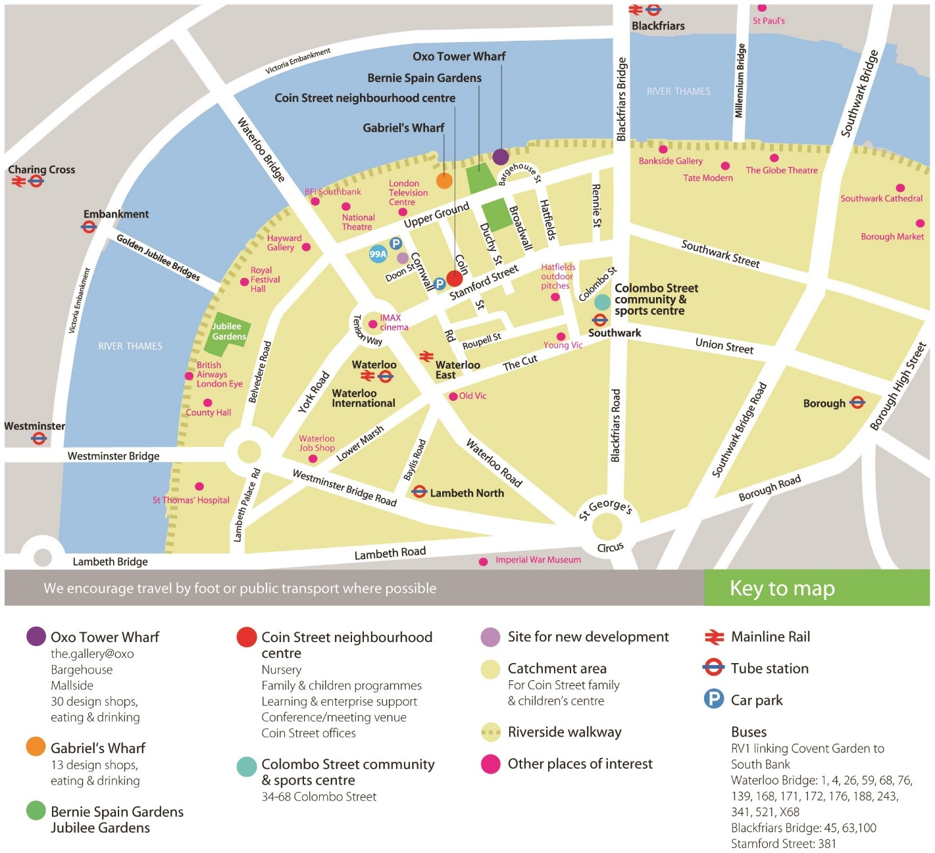

Our waiting list is prioritised on 5 points, stated below in order or priority:
- Children with SEND referrals
- Siblings of children who currently attend the nursery
- Families who live in our catchment area
- Families who work in our catchment area
- Families who live or work on the border of our catchment area
If you live or work outside of our catchment area you are welcome to apply but would be categorised as priority 5.
Our regular opening hours are 8am-6pm Monday to Friday. Until further notice we are operating reduced hours of 8:30am to 5:15pm due to the ongoing COVID-19 pandemic. When able to these temporary hours will be revised back to our regular hours.
Please note that written proof of the above statements must be submitted with this form; this may be a formal letter written by your workplace or school, or a copy of a household bill no more than three months old. Failure to provide these will result in delay when processing these forms.
By completing this form you have registered your interest in a place at Coin Street Nursery. You will now be placed on a waiting list whereby places are allocated on a priority rating scheme as noted above. You are not guaranteed a place until you have been specifically contacted and notified in writing with an offer.
For additional services provided by Coin Street Family and Children’s Centre
All information contained within this form will be treated with the strictest confidence and kept in accordance with the Data Protection Act 2018. Should you wish to discuss any of the points raised in the form in greater detail, please do not hesitate to speak to a member of the management team.
Please see our website for the latest privacy policy http://coinstreet.org/privacy-policy/

